Most of the initial requirements have answers on [www.odoo.yenthevg.com](http://www.odoo.yenthevg.com)

1. EMAIL

Create a new red button for Email/messages template which should show up on main customer window

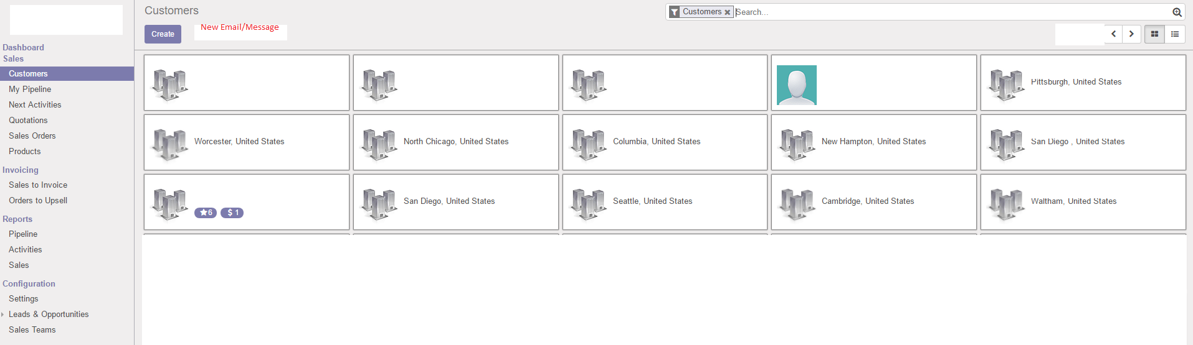

Create a new red button for Email/message template which should show up on every Customer / CustomerA window. In the screenshot below, Customer A = ABSALES

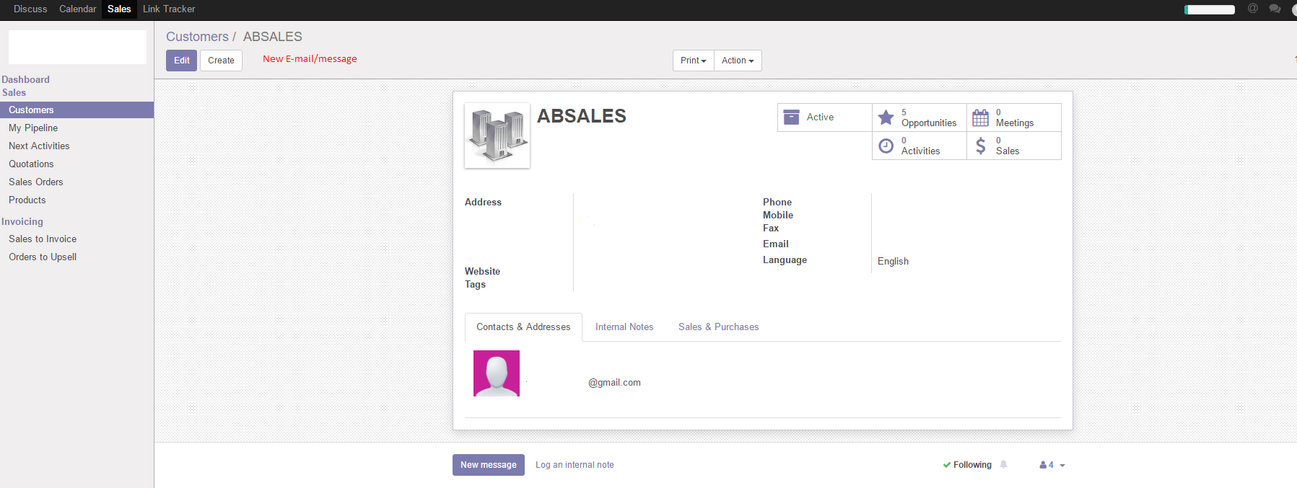

The new email button should lead to the full open popup create message window (b) below as opposed to the initial popup window a

a)

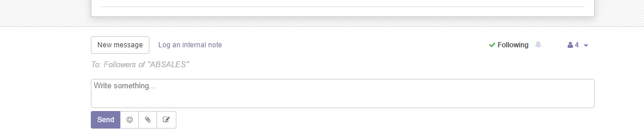

b) In other words, the new E-mail button created should lead to the action that results from clicking the 3rd icon to the right of the send button in pic (a) above and opens the window below

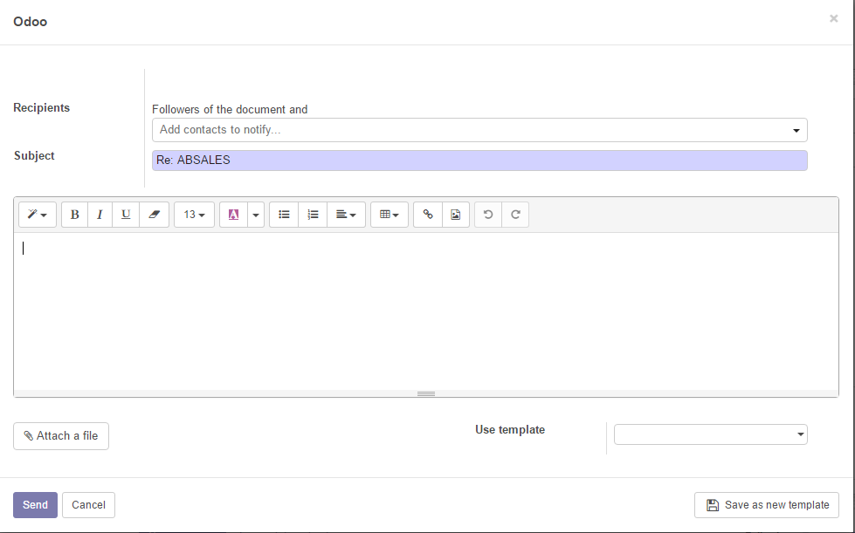

In the interface for new email as above, add other fields similar to a Cc.. and Bcc… line below



Make sure the code does not cause a reply all to send a message to other people on the Bcc line. In other words, if a crm user sends out an email to a group of people and each of them replies, their replies should only go to the crm user, and the mail.catchall.alias value

1b) EMAIL SIGNATURE

Signature line of messages sent should look more like as below. Currently the settings in the default odoo creates extra line spacing on the signatures and does not allow insertion of logos

Looks like this;

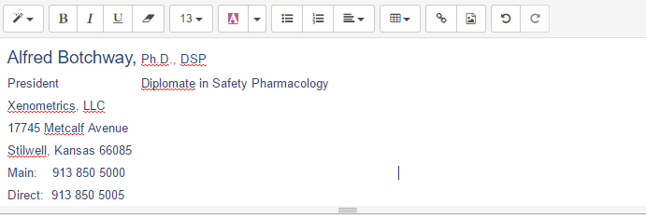

It needs to look more like this below

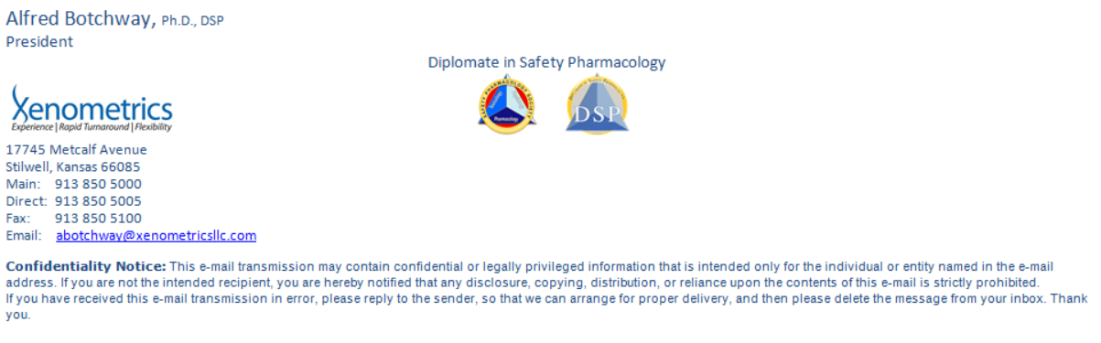

Could the email signature above be coded into python, so that it only asks for the crm user’s name, degrees, job title, and direct phone number, but does the rest of the formatting etc automatically.

1c) Recipient of email.

Currently the recipient gets an email from the crm user, the recipient sees the mail.catchall.alias “value” as the “reply to”. Can the reply to address automatically include the crm user’s email address hard coded into python in addition to the already existing mail.catchall.alias value? All subsequent emails/communication should include the crm user’s email address.

1d) Message strings

Once the email is sent, can the subject line be added to the string below the customer for every email/message that is subsequently sent? See below “where is the subject line”

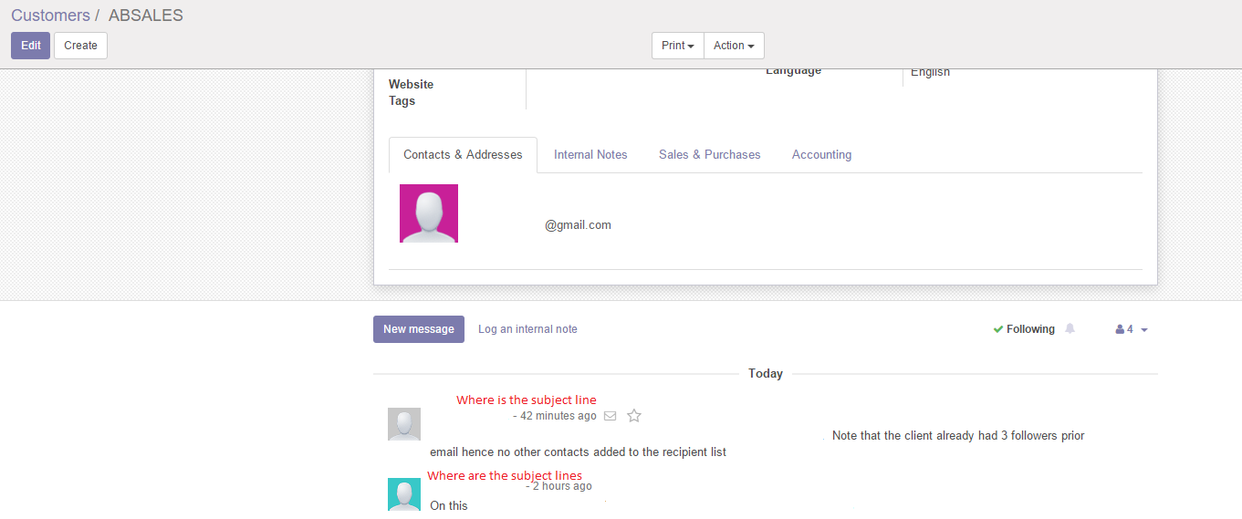

How can one of the messages with a subject line be opened and a follow up email sent? Do we need a separate sent folder created on left window for easy access?

QUOTATIONS changes to follow after initial email changes